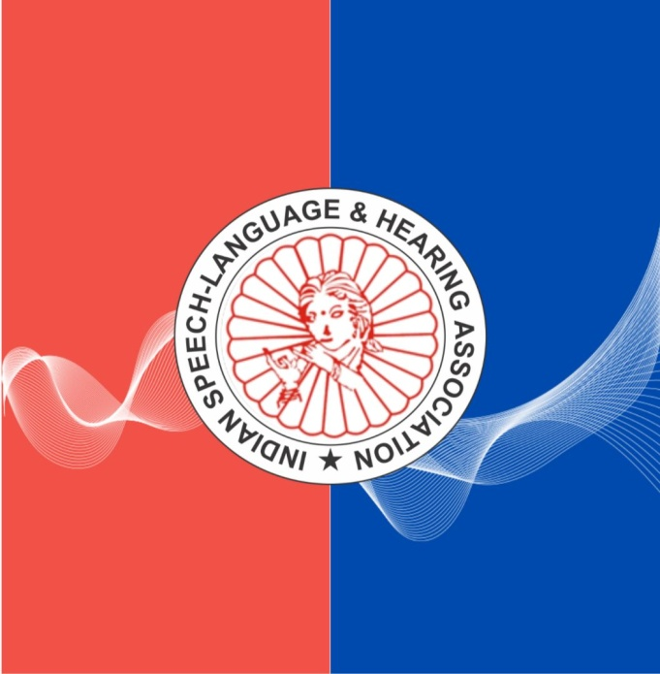
E-flag of ISHA
The EC of ISHA has chosen the above as the E-flag of ISHA. The red and blue colour in this e-flag signifies Audiology while the wave passing through them signifies Speech-Language and Communication.
Before finalizing this as our E-flag, we request the members to kindly provide their views on the same and write to secretary@ishaindia.org.in for any suggestions.

